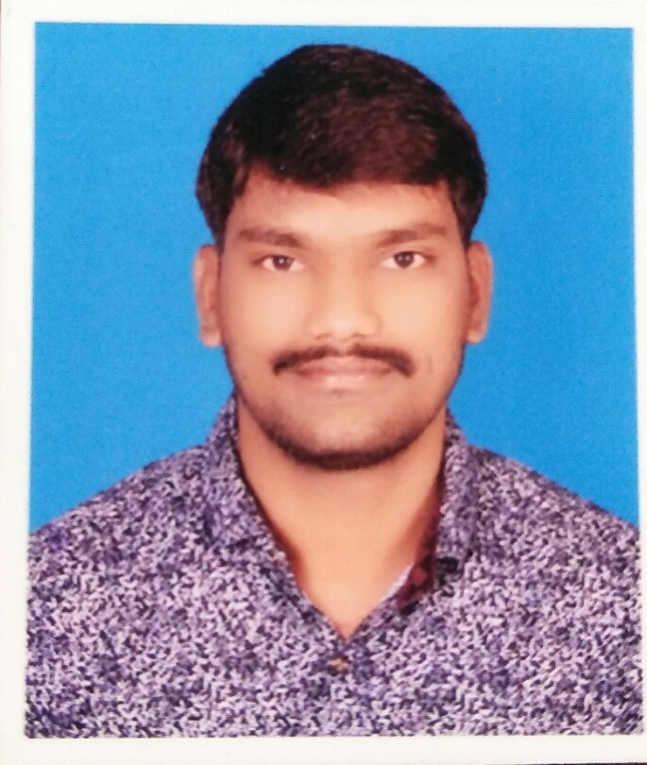
RESUME
ATUL HANMANT MALI
Email: atulsmali1925@gmail.com
Contact No. : 8975409370 / 7741802416
CAREER OBJECTIVE
To work with best of my abilities and skills in order to benefit my organization also to be better other in this competitive Time an influential position in the organization.
EDUCATIONAL QUALIFICATION
Sr. No. | Course | Board | Percentage | Year of Passing
1 | N.C.T.V.T.  ITI Gov. Delhi | Delhi | 68.16% | 2015
2 | ITI (Welder- Arc & Electric)  Gov. ITI Aundh (Khatav) | Delhi | 68.14% | 2013
3 | H.S.C. Science  R.B.Jr. College, Aundh | Kolhapur | 45.17% | 2008
4 | S.S.C.  S.S. High School, Aundh | Kolhapur | 53.17% | 2006

WORK EXPERIENCE
Oct-2014 - Oct-2015 Worked with UMW Motech Privet Ltd Talegaon,Pune as a welder for 1year
Welder Apprentice
Jan-2015 – Till Today Working with Volkswagen India Pvt. Ltd Mhalunge, Chakan, Pune. in a Body Shop as a Spot Welder.
Welder Contract Base

PERSONAL DETAILS
Address Aundh
Tal-Khatav, Dist-Satara, Maharashtra, Pin-415510
Date of Birth 25th September 1990
Gender Male
Nationality Indian
Marital Status Married
Languages Known Marathi, Hindi, English

DECLARATION
The above mentioned details are correct as per my knowledge, kindly consider my candidature provide me an opportunity to serve in your esteemed organization.

Date:
Place: ATUL HANMANT MALI

