ARVIND KUMAR SRIVASTAVA 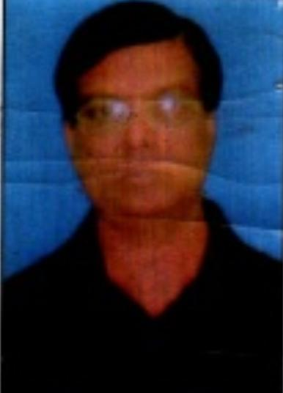
Add. 346 Nirala- Nagar,Arajibagh. Azamgarh UP – 276001- INDIA
Mob: +91 9335166700 / 9336656170
Email: - arvind. srivastava67@yahoo.com
OFFICE MANAGEMENT PROFESSIONAL
Targeting Position in Banking/Insurance/Financial Sector/Educational or Any Industry
Having 23year of experience in
Organizational and personal leadership / Sales support / General – Administration/Event Planning Expertise / Assignment & Project Management
--------------------------------------------------------------------------------------------------------------------------------------------
OBJECTIVE:-
Looking for challenging employment that will utilize my capabilities and skill set, to the maximum while offering excellent growth opportunities.
SUMMARY:-
- An incisive professional with 23year experience in administration/development.
- Previously designated as officiating senior finance officer in SAHARA India Varanasi.
- previously designated as Asst.regional.manager in futuready group.
- Well adaptive toward corporate culture and behavior & ability to work under pressure.
- A meticulous and quality – oriented individual with for details.
- Gifted with seeing everything not only with sight but with vision as well.
- Previously working as regional manager in real india group.
- Previously working as zonal manager in arise india group.
- Previously working as General manager in Arth multi state credit cooperative society ltd.
- previously working as project manager in Glister eduversity pvt.ltd.
- now working as senior manager in cliq a lan.com.

CARRER HIGHLIGHTS:-

- Administrator, Mt. carmal School (ICSE) Patna, June 1995-Nov, 1995.
- Administrator, Shivam central School (CBSE), Patna March 1995- May 1995.
- Office in charge, Sahara India, Varanasi from Aug. 1996 to 1999
- Officiating senior finance officer , Sahara India , Varanasi from 1999 to Oct. 2010
- previously working as a asst.regional manager in Sai Prasad group of companies / futureadey group Pune (Maharashtra) & posted at Varanasi since last 1Nov. 2010 to Dec.2015.
- previously working as regional manager in real india group.since January2017 to30 may 2017.
- previously working as RM /zonal manager in arise india from01 june2017 to feb.2018.
- previously working as General manager in arth credit cooperative society from march 2018 to may 2018.
- previously working as project manager in Glister eduversity pvt limited from june 2018 to 30 April 2019.[Education sector.educational support service develop in Bihar/up/Jharkhand/etc]
- now working as senior manager in cliq a loan.com from 01 may 2019 to ill date.
RESPONSIBILITY:-

- Performed general administrative function including the scheduling of appointment and meetings.
- Reporting to regional head, handling 70 employees, controlling of 10₌ branches.
- Resolved problem mediated disputes and handled customer complaints.
- Assisted the planning department in communication and distribution of sale information internally and externally.

SKILL:-
- Collected sale data and sales orders providing this information to the planning department.
- Responsible for the financial transactions including balance and deposit of the daily taking.
- Adapt quickly to diverse management and client style.
- Managed all office activities on a day to day basic.
- Preparing and maintaining MIS statements to be provided to the higher management.

EDUCATION QUALIFICATION-
- M.A.(MED. HISTORY)FROM ALLAHABAD UNIVERSITY IN THE YARE 1988
- B.ED( FROM PURVANCHAL UNIVERSITY IN THE YEAR 1990
- B.A. FROM ALLAHABAD UNIVERSITY INT THE YEAR 1986
- B.J. FROM HINDI SAHITYA SAMMELAN ALLAHABAD IN THE YEAR 1993
- R.T.M.(DIPLOMA IN RAIL TRANSPORT & MANAGEMENT) FROM RAIL TRANSPORT UNSTUITIE,NEW DELHI IN THE YEAR 2000
PERSONAL DETAIL:-
NAME : ARVIND KUMAR SRIVASTAVA
FATHER’S NAME : SHRI SHANKAR DEV LAL SRIVASTAVA
DATE OF BIRTH : 03/04/1967
SEX : MALE
MATERIAL STATUS : MARRIED
NATIONALITY : INDIAN
RELIGION : HINDU
LANGUAGE : HINDI/ENGLISH

DECLARATION:-
I HEREBY DECLARE THAT ALL THE STATEMENTS GIVEN ABOVE ARE CORRECT, TRUE AND COMPLETE TO THE BEST OF MY KNOWLEDGE AND BELIEF.

DATE------------------------------ SINGNATURE---------------------------
PLACE--------------------------

